Mandel Jewish Day School
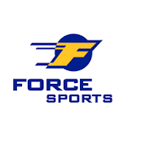
Away Games
Ruffing Montessori School
3380 Fairmount Blvd,
Cleveland, OH 44118
Gilmour Academy Middle School
34001 Cedar Rd,
Gates Mills, OH 44040
University School - Lower Campus
20701 Brantley Rd,
Shaker Heights, OH 44122
Gross Schechter School
27601 Fairmount Blvd,
Cleveland, OH 44124
Fuchs Mizrachi School
6600 Shaker Blvd,
Beachwood, OH 44122
Cornerstone Christian Academy
2846 Som Center Rd,
Willoughby, OH 44094
Andrews Osborne Academy
38588 Mentor Ave,
Willoughby, OH 44094
Old Trail School
2315 Ira Rd,
Akron, OH 44333
The Ratner School
27575 Shaker Blvd.
Pepper Pike, OH 44124

